A Macrobiotic Meal

*by*JENNY SANSOUCI*on JUNE 4, 2010*

I work right around the corner from an amazing Macrobiotic restaurant in Manhattan called [Souen](http://souen.net/" \o "Souen Macrobiotics" \t "_blank). Ever since my office moved to Soho, I’ve been getting Souen for lunch almost every day (literally). I have been getting so addicted to their steamed vegetables with brown rice & tahini-dill dressing that I knew it was time to create my own!!

**First of all…What is Macrobiotics?**  
From [Souen.net](http://souen.net/):  
“Macrobiotics is thought of as **a path to health and healing with traditional Japanese natural foods.**

***[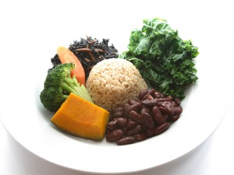](http://healthycrush.com/wp-content/uploads/2010/06/macroplate1.jpg)***

*Macro Plate from Souen*

It is thought that by eating balanced foods such as grains and vegetables that are more local and in season, we can **maintain good physical and spiritual health and live in harmony with nature.** A typical Macrobiotic plate will consist of grains, beans, seaweed, vegetables and vegetable protein, such as tofu, seitan, beans or tempeh.  Macrobiotics dictates eating food in a natural way – **unrefined and unprocessed.”** (*Read more at*[*Souen.net*](http://souen.net/macrobiotics/whats-macrobiotics))

The meal I’m creating doesn’t involve every one of those elements listed above, but it is definitely macro-inspired! The vegetables used in Souen’s steamed vegetable dish are broccoli, carrots and my newest love, kabocha squash. Unfortunately I couldn’t find a kabocha squash at Whole Foods (I think I may need to check out a Japanese grocery store to find this squash year-round), so I got an acorn squash instead.

Here’s what you need to create my favorite Souen meal:

* 1 kabocha squash (or acorn if you can’t find kabocha)
* 1 head of broccoli
* 1 large carrot
* 1 cup brown rice (uncooked. will make about 3 cups cooked)
* gomasio *(sesame seed sea salt, optional)*
* tahini-dill dressing *(instructions below)*

**Tahini-Dill dressing** (I don’t know what they put into their tahini-dill dressing at Souen, so this is my creation):

* 3/4 cup of tahini (sesame paste)
* 1 tbsp white miso
* 1 tbsp tamari
* juice of 1 lemon
* 1 clove garlic
* 1/2 tbsp fresh dill
* 1/2 cup water
* Blend all dressing ingredients together in a blender/food processor. You’ll definitely have extra dressing, so cut down the recipe if you want to make less.

[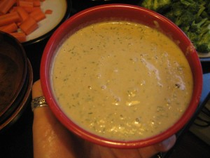](http://healthycrush.com/wp-content/uploads/2010/06/IMG_9497.jpg)

***Note:***I created the tahini from scratch by soaking raw sesame seeds for a few hours and then using my Vita-Mix to blend them into a paste (about 2 cups of soaked sesame seeds mixed with 1/2 cup water). You can buy tahini in a jar at the store, too, just like any other nut butter.

* Cook your brown rice (boil for about 45 minutes).
* Chop kabocha or acorn squash in half and scoop out the seeds. Chop into 5-6 smaller pieces and steam until tender (about 15-20 minutes)

[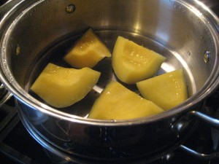](http://healthycrush.com/wp-content/uploads/2010/06/IMG_9496.jpg)

* Chop carrots and broccoli into bite-sized pieces and steam until they reach desired tenderness.
* When the rice is cooked, sprinkle it with gomasio and drizzle with a small portion of the tahini-dill dressing, and mix well.
* [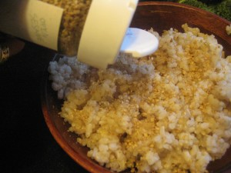](http://healthycrush.com/wp-content/uploads/2010/06/IMG_9501.jpg)Top the rice with the steamed veggies.
* Drizzle veggies with tahini-dill dressing. [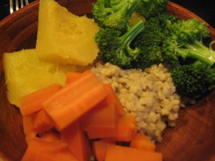](http://healthycrush.com/wp-content/uploads/2010/06/IMG_9512.jpg)

[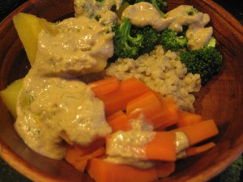](http://healthycrush.com/wp-content/uploads/2010/06/IMG_9513.jpg)

…..then I like to mix it all around into a mush. :)

[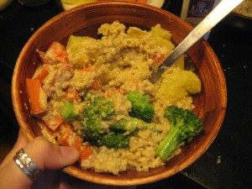](http://healthycrush.com/wp-content/uploads/2010/06/IMG_95301.jpg)

I love this meal so much…It’s so simple, but it will keep you feeling satisfied for hours. I think the veggies, rice & tahini are super filling on their own, but you can add tofu, beans, or whatever else you’d like too. :) ENJOY!!!